**HOMECARE SYSTEM**

**Short-term product**

**Formulae and Calculations**

**by**

**Phuong Pham**

Version 0.1.2

Version date: Oct24, 2013

**Working Draft**

Revision History

|  |  |  |  |
| --- | --- | --- | --- |
| **Date** | **Version** | **Description** | **Author** |
| Sep 23, 2013 | 0.1 | Initial Draft | Phuong Pham |
| Oct10, 2013 | 0.1.1 | Revised Draft | Phuong Pham |
| Oct24, 2013 | 0.1.2 | Update Body measurement, Sleep, Position, Fertility features, Conversion Formulas | Phuong Pham |

Contents

Revision History 2

1 Scope 5

2 Features 5

2.1 Skin Temperature 5

2.1.1 Thresholds 5

2.1.2 Help/Info 5

2.2 Body Measurement 5

2.2.1 Body Mass Index (BMI) 5

2.2.2 Ideal weight (IW) 6

2.2.3 Waist to Hip Ratio (WHR) 6

2.2.4 Body Fat Percentage (BF%) 7

2.2.5 Lean Body Weight (LBW) 8

2.2.6 Basal Metabolic Rate (BMR) 8

2.2.7 Calories needs per day 9

2.2.8 Metabolic age 9

2.2.9 Help/Info 9

2.2.10 Calculate age from date of birth 9

2.2.11 Color definition 9

2.3 Heart Rate 10

2.3.1 Maximum HR estimation method 1 10

2.3.2 Maximum HR estimation method 2 10

2.3.3 Mean HR [bpm] 11

2.3.4 Std HR [bpm] 11

2.3.5 Mean RR [ms] 11

2.3.6 SDNN [ms] 11

2.3.7 RMSSD [ms] 11

2.3.8 NN50 count [ms] 12

2.3.9 pNN50 [%] 12

2.3.10 Diagnosis based on HR rest 12

2.3.11 Diagnosis based on HRV parameters 13

2.3.12 Help/Info 13

2.4 Pulse oximeter SpO2 13

2.4.1 Tracking mode 13

2.4.2 Thresholds 13

2.4.3 Help/Info 14

2.5 Fitness 16

2.5.1 Heart rate Exercise 16

2.5.2 Target heart rate for single mode 16

2.5.3 Target heart rate zones for multi-stage mode 16

2.5.4 Target HR zone calculation 16

2.5.5 Multi-stage Heart rate Exercise Programs 17

2.5.6 Pedometer 17

2.5.7 Help/Info 18

2.6 Stress 19

2.6.1 Stress introduction 19

2.6.2 Model 20

2.6.3 Diagnosis 20

2.6.4 Help/Info 20

2.7 Sleep 20

2.7.1 Sleep introduction 20

2.7.2 Parameters 21

2.7.3 Model 21

2.7.4 Diagnosis 21

2.7.5 Help/Info 22

2.8 Position 22

2.8.1 Patient Position Monitoring 22

2.8.2 Position detection 23

2.8.3 Help/Info 25

2.9 Fertility 25

2.9.1 Parameters 25

2.9.2 Statistics 25

2.9.3 Advanced Prediction 26

2.9.4 Help/Info 26

3 Conversion Formulas 27

4 References 27

# Scope

The document is intended for software developers developing algorithm and calculations as well as for firmware developers developing for the sensor board if needed. The document describes the formulae, calculation and algorithm using for building features, analyzing data and diagnosing health issues.

# Features

## Skin Temperature

Skin temperature vs. Body temperature

Pulse artery temperature may close to body temperature (shoulduse IR temperature sensor)

Need to offset skin temperature vs. body temperature (calibration)

### Thresholds

|  |  |  |  |
| --- | --- | --- | --- |
| Thresholds type | Body Temperature  (at rectal or ear) | Evaluate | Recommendation |
| Low threshold | < 97oF (36.1oC) | Low body temperature (hypothermia) | Low body temperature (hypothermia) |
| High threshold | >100.4oF (38oC) | Fever | Fever |
| Very High threshold | >103.9oF (39.9oC) | _ High Fever  _ If combined symptoms include dry skin, rapid, strong pulse and dizziness, headache, nausea, user is over 65 -> Heat stroke | _ If it lasts more than a couple days or has no obvious cause, meaning it is not accompanied by cold or flu symptoms, user should see your doctor.  _ If diagnosed as heat stroke, user needs to cool down quickly and call for help immediately. |

### Help/Info

Show guide how to calibrate Skin temperature: TBD

Show Body Temperature (at rectal or ear) thresholds

## Body Measurement

### Body Mass Index (BMI)

Body Mass Index (BMI):a measure for human body shape based on an individual's weight and height

BMI = weight[kg] / (height[m])^2

BMI = (weight[lb] / (height[in])^2) x 703.06957964

|  |  |  |
| --- | --- | --- |
| BMI | Diagnose | Health risk |
| BMI < 16 | Severely underweight | Risk of developing problems such as nutritional deficiency and osteoporosis |
| 16 <= BMI <18.5 | Underweight | Risk of developing problems such as nutritional deficiency and osteoporosis |
| 18.5 <= BMI <25 | Normal | Low Risk |
| 25 <= BMI < 30 | Overweight | Moderate risk of developing heart disease, high blood pressure, stroke, diabetes |
| 30<= BMI < 35 | Obese | High risk of developing heart disease, high blood pressure, stroke, diabetes |
| BMI > 35 | Very Obese | High risk of developing heart disease, high blood pressure, stroke, diabetes |

### Ideal weight (IW)

* Calculate idea weight based on formula:

[Devine74]Men: Ideal Body Weight (in kg) = 50 kg + 2.3 kg per inch over 5 feet.

[Robinson83]Women: Ideal Body Weight (in kg) = 49 kg + 1.7 kg for each inch over 5 feet

* Calculate idea weight based on medical recommendation (BMI = 19-25):

weight[lb] = BMI / (height[in])^2 / 703.06957946

weight[kg] = BMI / (height[m])^2

* Evaluate current weight with ideal weight: based on s = (current weight – ideal weight)

If s > 0: “Your current weight excesses ideal weight s kg/lb”

If s < 0: “Your current weight is under ideal weight s kg/lb”

If s = 0: “You have perfect weight”

### Waist to Hip Ratio (WHR)

The WHR has been used as an indicator or measure of the health of a person, and the risk of developing serious health conditions.WHR is used as a measurement of obesity, which in turn is a possible indicator of other more serious health conditions.

Waist: Inches at NARROWEST point (NOTE: Measure one inch above navel).

Hip: Inches at WIDEST point.

WHR = waist/hip

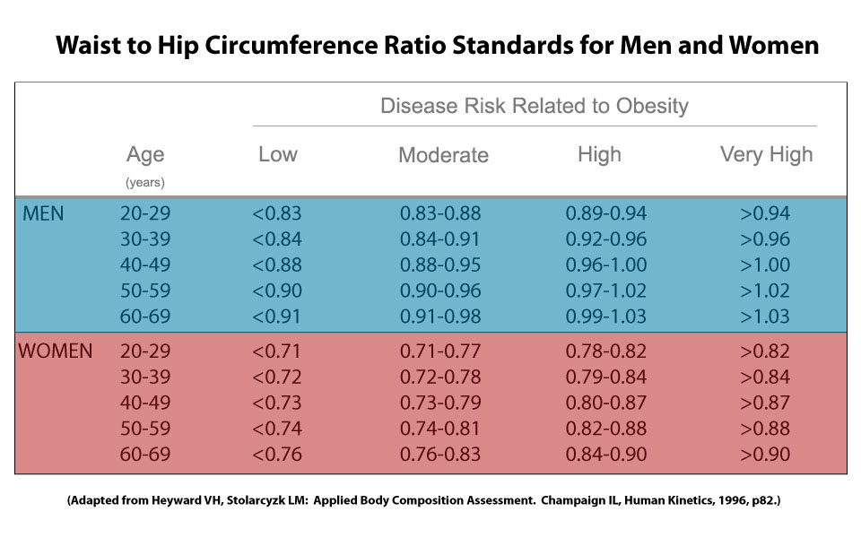

|  |  |  |
| --- | --- | --- |
| Gender | WHR | Abdominal Obesity |
| Male | < 0.9 | No |
|  | >= 0.9 | Yes |
| Female | < 0.85 | No |
|  | >= 0.85 | Yes |

### Body Fat Percentage (BF%)

The body fat percentage of a person is the total weight of fat divided by total weight; body fat includes essential body fat and storage body fat. Essential body fat is necessary to maintain life and reproductive functions. The percentage of essential body fat for women is greater than that for men, due to the demands of childbearing and other hormonal functions. The percentage of essential fat is 2 - 5% in men, and 10 - 13% in women[ACE (2009) ]

* Calculate BF% method 1 : based on BMI [Deurenberg]fomular 2

BF % = (1.29 x BMI) + (0.20 x Age) - (11.4 x gender) - 8.0

where gender is 1 for male and 0 for female

* Calculate BF% method 2 : CUN-BAE [Gómez-Ambrosi12]

BF% = –44.988 + (0.503 x age) + (10.689 x sex) + (3.172 x BMI)

– (0.026 x BMI^2) + (0.181 x BMI x sex) – (0.02 x BMI x age)

– (0.005 x BMI^2 x sex) + (0.00021 x BMI^2 x age)

where male = 0 and female = 1 for sex, and age in years,

* Calculate BF% method 3 : US Navy

Men:

BF% = (86.01 x LOG10((waist) - (neck))) - (70.041 x LOG10(height)) + 36.76

Women:

BF% = (163.205 x LOG10((waist) + (hip) - (neck))) - (97.684 x LOG10(height)) - 78.387

where waist, neck, height are measured in inches.

* Evaluate based on WHO

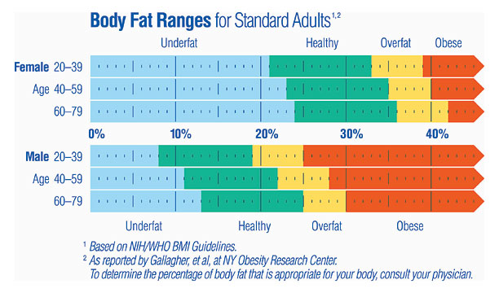

* Evaluate based on Tanita chart

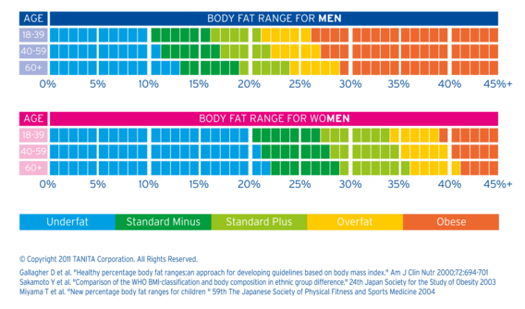

* Evaluate based on Brainy chart

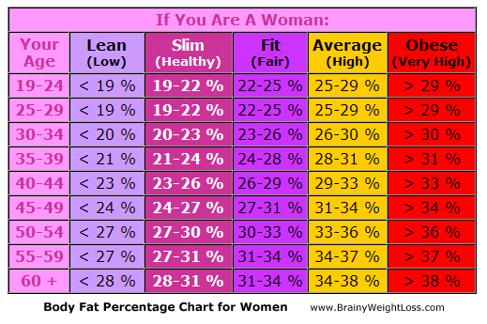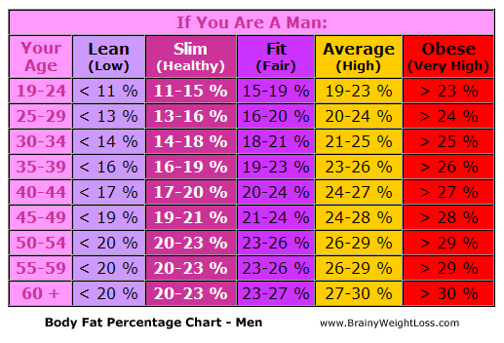

### Lean Body Weight (LBW)

Lean Body Weight refers to the sum of the weight of your bones, muscles and organs... basically the sum of everything other than fat in your body. The formula for lean body mass using the method of James1,2 is

Men: LBW = (1.10 x Weight(kg)) - 128 x( Weight(kg)^2/(100 x Height(m))^2)

Women:LBW = (1.07 x Weight(kg)) - 148 x( Weight(kg)^2/(100 x Height(m))^2)

### Basal Metabolic Rate (BMR)

Basal metabolic rate (BMR), and the closely related resting metabolic rate (RMR), is the amount of [energy](http://en.wikipedia.org/wiki/Food_energy) expended daily by humans and other animals at rest.

Basal Metabolic Rate is synonymous with Basal Energy Expenditure or BEE. BMR measurements are typically taken in a darkened room upon waking after 8 hours of sleep; 12 hours of fasting to ensure that the digestive system is inactive; and with the subject resting in a reclining position.

RMR stands for Resting Metabolic Rate, and is synonymous with Resting Energy Expenditure or REE. RMR measurements are typically taken under less restricted conditions than BMR, and do not require that the subject spend the night sleeping in the test facility prior to testing.

* Calculate BMR/RMR method 1 (Mifflin)

For men:

BMR = 5 + (10 x weight in kg) + (6.25 x height in cm) – (5.0 x age in years)

For women:

BMR = -161 + (10 x weight in kg) + (6.25 x height in cm) – (5.0 x age in years)

* Calculate BMR/RMR method 2 (Katch-McArdle)

BMR = 370 + 21.6 x LBM

where LBM in kg

* Evaluate BMR: TBD

### Calories needs per day

As BMR and RMR only represent resting energy expenditure, an adjustment must be made to reflect your activity level. This is done by multiplying your BMR or RMR by an activity factor (McArdle et al 1996). Note that the following activity factors also take into account The Thermic Effect of Food:

|  |  |  |
| --- | --- | --- |
| Activity Factor | Category | Definition |
| 1.2 | Sedentary | Little or no exercise and desk job |
| 1.375 | Lightly Active | Light exercise or sports 1-3 days a week |
| 1.55 | Moderately Active | Moderate exercise or sports 3-5 days a week |
| 1.725 | Very Active | Hard exercise or sports 6-7 days a week |
| 1.9 | Extremely Active | Hard daily exercise or sports and physical job |

* Calculate Calories needs per day

calories_needs = BMR * activity_factor;

### Metabolic age

Metabolic Age refers to a number calculated by comparing your Basal Metabolic Rate to the Basal Metabolic Rate average of your chronological age group [Wiki]

* Calculate metabolic age

diff_weight = weight – ieal_weight;

metabolic_age = age - 0.143 * (abs(diff_weight))^(1/3) + 0.236 * diff_weight;

* Evaluate Metabolic age: based on t = (current age – metabolic age)

If t > 0: “You are younger than your real age t years”

If t < 0: “You are older than your real age t years”

If t = 0: “Your real age is the same as your metabolic age”

### Help/Info

Display explanations of body measurement parameters, formulae except metabolic age formula.

Display guides how to measure waist, hip, neck.

### Calculate age from date of birth

Calculating age using sql server function: check the following functions

DATEDIFF(day,DOB,GETDATE())/365.242199

FLOOR(DATEDIFF(day,DOB,GETDATE())/365.242199)

### Color definition

#### BMI

|  |  |
| --- | --- |
| Evaluation | Color |
| Severely underweight | Blue |
| Underweight | Light Blue |
| Normal | Green |
| Overweight | Yellow |
| Obese | Orange |
| Very Obese | Red |

#### WHR

|  |  |
| --- | --- |
| Evaluation | Color |
| Low | Green |
| Moderate | Yellow |
| High | Orange |
| Very high | Red |

#### BF% - WHO

|  |  |
| --- | --- |
| Evaluation | Color |
| Underfat | Light Blue |
| Healthy | Green |
| Overfat | Orange |
| Obese | Red |

#### BF% - Tanita chart

|  |  |
| --- | --- |
| Evaluation | Color |
| Underfat | Light Blue |
| Standard minus | Green |
| Standard plus | Yellow |
| Overfat | Orange |
| Obese | Red |

#### BF% - Brainy chart

|  |  |
| --- | --- |
| Evaluation | Color |
| Lean (Low) | Light Blue |
| Slim (Healthy) | Green |
| Fit (Fair) | Yellow |
| Average (High) | Orange |
| Obese (Very High) | Red |

## Heart Rate

### Maximum HR estimation method 1

[Kolata01] method:

Men: age adjusted HRmax = 220 - age

Women: age adjusted HRmax = 226 - age

### Maximum HR estimation method 2

[Gatti96] method:

Men: age adjusted HRmax = 205.8 - (0.685 × age)

[Gulati10]

Women: age adjusted HRmax = 206 - (0.88 × age)

### Mean HR [bpm]

Mean of a data vector X.

$$\overline{x}=\frac{1}{N}\sum_{i=1}^{N}{x_{i}}$$

where N is the number of elements in the sample.

### Std HR [bpm]

The unbiased standard deviation s of a data vector X.

$$s=\sqrt{\frac{1}{N-1}\left(\sum_{i=1}^{N}{{\left(x_{i}-\overline{x}\right)}^{2}}\right)}$$

### Mean RR [ms]

The mean of the all NN intervals (or RR intervals), calculated over short periods 5 minutes.

### SDNN [ms]

The standard deviation of the all NN intervals (or RR intervals), calculated over short periods 5 minutes.



$$SDNN=\sqrt{\frac{1}{N-1}\left(\sum_{i=1}^{N}{{\left({RR}_{i}-\overline{RR}\right)}^{2}}\right)}$$

where N is the number of NN intervals in the sample.

### RMSSD [ms]

The square root of the mean of the sum of the squares of differences between adjacent NN intervals

$$RMSSD=\sqrt{\frac{1}{N-1}\left(\sum_{i=1}^{N-1}{{\left({RR}_{i+1}-{RR}_{i}\right)}^{2}}\right)}$$

### NN50 count [ms]

Number of pairs of adjacent NN intervals differing by more than 50 ms in the entire recording; three variants are possible counting all such NN intervals pairs or only pairs in which the first or the second interval is longer

### pNN50 [%]

NN50 count divided by the total number of all NN intervals

### Diagnosis based on HR rest

**HRrest< 50BPM**

_Diagnostics: Bradycardia

_Recommendation: See your doctor

Bradycardia is defined as a heart rate less than 60 beats per minute although it is seldom symptomatic until below 50 bpm when a human is at total rest. This number can vary as children and small adults tend to have faster heart rates than average adults. Bradycardia may be associated with medical conditions such as hypothyroidism.

**HRrest> 100 BPM**

_Diagnostics: Tachycardia

_Recommendation: See your doctor if you are not in physiological conditions

1. Exercise

2. Pregnancy

3. Emotional conditions such as anxiety or stress.

Tachycardia is a resting heart rate more than 100 beats per minute. This number can vary as smaller people and children have faster heart rates than average adults.

Physiological conditions when tachycardia occurs are:

1. Exercise

2. Pregnancy

3. Emotional conditions such as anxiety or stress.

Pathological conditions when tachycardia occurs are:

1. Fever

2. Anemia

3. Hypoxia

4. Hyperthyroidism

5. Hypersecretion of catecholamines

6. Cardiomyopathy

7. Valvular heart diseases

### Diagnosis based on HRV parameters

A reduction of HRV is a signal of in several cardiological and noncardiological diseases such as Myocardial Infarction, Diabetic Neuropathy, Cardiac Transplantation, Myocardial Dysfunction, Tetraplegia.

Recommendation: See your doctor if having reduced HRV.

### Help/Info

Show guide how to measure HR rest: TBD

Information about how to estimate HR max: refer information above.

Clinical tips to minimize movement artifact: TBD

Clinical tips to minimize pressure artifact: TBD

Clinical tips to minimize cold artifact: TBD

## Pulse oximeter SpO2

### Tracking mode

* Normal monitoring
* Sleep apnea syndrome monitoring
* COPD patients monitoring
* Patients on long-term oxygen therapy monitoring
* Asthma patients monitoring
* Acute respiratory infections monitoring

### Thresholds

* Normal monitoring: check SpO2 level<90%, if yes
  + recommendation: See your doctor
* Sleep apnea syndrome monitoring: check series of SpO2 level<90%, or check SpO2 values changes <=4%, if yesrequesting clinical score, if there is any of clinical score, see your doctor.

* Clinical Score

_ Loud and habitual snoring

_ Interrupted breathing

_ Excessive daytime sleepiness: Epworth Sleepiness Scale

_ Body mass index greater than 25

_ Use of hypotensive medications or blood pressure greater or equal to 140/90

* Epworth Sleepiness Scale Situations Score

_ Sitting and reading

_ Watching TV

_ Sitting inactive in a public place (e.g a theater or a meeting)

_ As a passenger in a car for an hour without a break

_ Lying down to rest in the afternoon when circumstances permit

_ Sitting and talking to someone

_ Sitting quietly after a lunch without alcohol

_ In a car, while stopped for a few minutes in traffic

* Epworth Sleepiness Scale

_ 0: no chance of dozing

_ 1: slight chance of dozing

_ 2: moderate chance of dozing

_ 3: high chance of dozing

If your total Epworth Sleepiness Scale Situations Score is 6 or under, you are doing well and deserve a pat on the back; if your score is 7 or 8, you are average; if your score is 9 and above, you have a problem and should seek help.

* COPD patients monitoring: check SpO2 level<92%, if yes
  + Recommendation: see your doctor immediately
* Patients on long-term oxygen therapy monitoring: check SpO2 level<90%, if yes
  + Recommendation: see your doctor immediately
* Asthma patients monitoring: check SpO2 level<92% (before treatment with bronchodilators), if yes
  + Recommendation: see your doctor immediately if
* Acute respiratory infections monitoring[Homes09]: check SpO2 level<92% (in a previous healthy individual who is not receiving oxygen therapy)
  + checking clinical features CRB65
    - Confusion (new onset)
    - Respiratory rate >30 / minute
    - Blood pressure

systolic<90mmHg,

diastolic<60mmHg

* + - 65 years of age or older
  + Recommendation: Score one point for each of the CRB65 components. Patients with a score of 1 or 2 may need hospital admission and those with scores of 3 or 4 need urgent hospital admission, especially if Sp02<92%

### Help/Info

* Display tracking mode: refers above
* Limitations

|  |  |  |
| --- | --- | --- |
| Limitations [Anzueto10] | SpO2 values < 80% | Pulse oximeters can overestimate oxygen saturation, particularly in those with darkly pigmented skin. [Feiner07] |
| Poor perfusion (cold digits) due to hypotension, hypovolemic shock, cold environment, or cardiac failure | May result in the machine not providing a reading. [Holmes09] |
| Anemia | Oxygen delivery to tissues is inadequate but SpO2 is normal. |
| Carbon monoxide poisoning | Carbon monoxide binds to hemoglobin, resulting in inadequate oxygen transport despite normal pulse oximeter readings. [Holmes09] |
| Certain antiretroviral medications | Affect oxygen’s affinity for hemoglobin. [Jubran04] |
| Movement, shivering patient, heart arrhythmias | Oximeter may not be able to identify an adequate pulse signal. [Holmes09] |
| Nail polish, dirt, artificial nails | Can cause false low readings or no readings. [Holmes09] |
| Bright artificial light (as in an operating room) | Can cause false low readings. [Holmes09] |
| Older patients | Normal oxygen saturation levels may be slightly lower than in younger people. [Holmes09] |
| Sickle cell disease | Does not confound SpO2 results in adults [Ortiz99], but may in children. [Blaisdell00] |

* Warning signs [Anzueto10]
  + A sudden drop in your oxygen level—for example during a severe cold or the flu—can be a sign of trouble. Call your doctor if your normal oxygen setting is no longer maintaining your saturation and you feel sick. Also, call your supplier if you feel your oxygen system is not working.
  + A high resting pulse rate of greater than 100 or a low pulse of less than 40 (check with your doctor to determine your individual pulse ranges) are also reasons to call your doctor.
  + During a severe breathing attack, it is possible to have a normal oxygen level. Seek medical help if you have severe shortness of breath, wheezing, or increased pulse rate, even if your oxygen saturation is normal.
* Troubleshooting [Anzueto10]
  + Nail polish (especially dark shades) and/or artificial nails may affect the oximeter’s performance.
  + Accurate oxygen measurements by oximetry require a good blood flow through the tissues. When your fingers are cold, the blood flow is reduced and poor or abnormal readings are possible. Warming the hands by rubbing them together or with warm water helps improve blood flow.
  + Do not smoke! Smoking reduces the amount of oxygen reaching your tissues—while the oximeter willfalsely suggest that oxygen level is satisfactory.
  + You may be more short of breath when your oxygen is low, but oxygen alone may not fully relieve shortness of breath. Exercise training and pulmonary rehabilitation are usually helpful in this situation.
* Diseases related to the decrease in SpO2%: TBD

## Fitness

### Heart rate Exercise

There are 2 operating modes:

* Single mode: only one Target Heart rate value during the exercise
* Multi-stage mode: There are multiple stages during the exercise. Each stage can be set with different Target Heart rate Zone and Time.

### Target heart rate for single mode

* General method: Target HR = % Intensity x HRmax

where% Intensity = 65%–85%

* [Karvonen88] method: THR = ((HRmax − HRrest) × % Intensity) + HRrest  
  where % Intensity = 50%–85%

### Target heart rate zones for multi-stage mode

**Zone 1**: Light Exercise – Healthy Heart Maintenance

**Zone 2**: Weight Loss – Burn Fat & Calories

**Zone 3**: Base - Aerobic – Increase stamina & endurance (Aerobic threshold)

**Zone 4**: Conditioning – Fitness conditioning, muscle building, and athletic training (Anaerobic threshold)

**Zone 5**: Athletic elite – Athletic training and endurance (Maximum)

### Target HR zone calculation

* General method: Target HR = % Intensity x HRmax

where% Intensity for

Zone 1: 50% - 60%

Zone 2: 60% - 70%

Zone 3: 70% - 80%

Zone 4: 80% - 90%

Zone 5: 90% - 100%

* Zoladz method: Target HR = HRmax − Adjuster ± 5 bpm

whereAdjuster for

Zone 1: 50 bpm

Zone 2: 40 bpm

Zone 3: 30 bpm

Zone 4: 20 bpm

Zone 5: 10 bpm

### Multi-stage Heart rate Exercise Programs

For Example: if you want to burn fat to lose weight, select your favorite exercise and keep within 60-70% of your maximum heart rate, based on your age, for at least 30 minutes a day, 3 times a week.

* Default exercise program settings: 3 stages

Stage 1: Warm up

Heart rate zone: Zone 1

Time: 5 min

Stage 2: Fat burn

Heart rate zone: Zone 2

Time: 20 min

Stage 3: Recovery

Heart rate zone: Zone 1

Time: 5 min

* Example exercise program: 3 stages

Stage 1: Warm up

Heart rate zone: Zone 1

Time: 5 min

Stage 2: aerobic

Heart rate zone: Zone 3

Time: 20 min

Stage 3: Recovery

Heart rate zone: Zone 1

Time: 5 min

### Pedometer

* Step count: **algorithm** (thuật toán) to get accumulated step count from accelerometer

To implement a pedometer algorithm, follow the steps given below.

1) First go through the sensor datasheet and find what is the minimum sampling rate or BW that it supports. Configure it to lowest sampling rate (Typically 25 Hz is the min range).

2) Now you need to understand all physical movements are within 5 Hz range. So implement a low pass filter of 5Hz cutoff (better use FIR low pass filter). So you can have a FIFO buffer (say length = 5) and filter it.

3) Now you have the meaningful data. Next step is pattern recognition based on **slope** (độ dốc, nghiêng) detection technique. Typically a walk has a positive slope and negative slope with one zero crossing. So you need to identify all three and benchmark a minimum threshold.

4) Keep identifying the above pattern and hold it to check stability and update once you find it is stable.



The TI pedometer algorithm API uses sensor data sampled from the MEMS 3-axis accelerometer at a rate of 50 Hz to detect stepping motion in any axis. This feature allows multiple wearable configurations such as on the waist, in a shirt or pants pocket, or on the wrist.

As motion is detected, the pedometer algorithm starts calculating and accumulating step counts. After thefirst ten (approximately) valid steps have been detected, the step count is updated with the latest stepcount. As motion continues, the algorithm produces an updated step count as each step is taken. If themotion stops, the algorithm resets and waits for the next ten valid steps to be detected.

Ref: http://software-dl.ti.com/msp430/msp430_public_sw/mcu/msp430/MSP430_Pedometer/latest/index_FDS.html

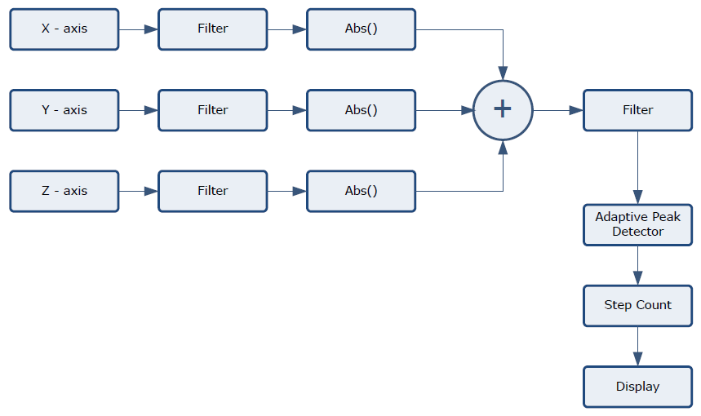

* Step length (inch)

Women: step_length = height x 0.413

Men: step_length = height x 0.415

Or step_length = height x (0.413 + gender x 0.002)

where gender = 1 for male and = 0 for female

* Distance (miles)

distance = Step_counts x step_length

* Duration (minute)

duration = current_time – start_time

* Average Speed (miles/hour)

average_speed = distance/duration

* Calories burned
  + [Keytel05] method: without VO2max:

Men: C/min = (-55.0969 + 0.6309 x HR + 0.1988 x weight + 0.2017 x age) / 4.184

Women: C/min = (-20.4022 + 0.4472 x HR - 0.1263 x weight + 0.074 x age) / 4.184

Inputs: gender, weight[kg], age[years], heart rate[bpm], duration[min]

Outputs: calories[kcal] burned per min, C stands for Kcals

* + [Dugas05] method: without VO2max:

Men: C/min = (-16.1 + 0.194 x HR + 0.311 x pmHR - 0.02 x HR x pmHR - 0.597 x weight + 0.353 x age + 0.007 x HR x weight) / 4.184

Women: C/min = (-20.2 + 0.397 x HR + 0.155 x pmHR - 0.001 x HR x pmHR - 0.174 x weight - 0.08 x age + 0.001 x HR x weight) / 4.184

Inputs: gender, weight[kg], age[years], heart rate HR[bpm], pevious minute heart rate pmHR[bpm], duration[min]

Outputs: calories[kcal] burned per min, C stands for Kcals

### Help/Info

Information about target HR: refers above.

Information about target HR zones: refers above.

Default exercise program settings example: refers above.

Information about Calories burned calculation methods: refers above.

## Stress

### Stress introduction

Stress is a physiological response to the mental, emotional, or physical challenges that we encounter. Our application uses activity-aware, multi-modal system that combines accelerometer, heart rate variability (HRV), and Galvanic Skin Response (GSR) information to differentiate between physical activity and mental stress.

#### HRV

HRV is commonly used as a quantitative markerdescribing the activity of the autonomic nervous system during stress. HRVparameters are time domain features which are extracted from Photoplethysmography (PPG) as in Heart rate feature. These parameters are:

* Mean HR
* Std HR
* Mean RR
* Std RR (SDNN)
* RMSSD
* pNN50

and they are calculated over a window duration is 60 seconds.

#### GSR

There are two major components for GSR analysis. Skinconductance level (SCL) is a slowly changing part of the GSR signal, and it canbe computed as the mean value of skin conductance over a window of data. Afast changing part of the GSR signal is called skin conductance response (SCR),which occurs in relation to a single stimulus. Widely used parameters for GSRinclude the amplitude and latency of SCR and average SCL value.

GSR signal should be pre-processed to reduce noise. The analysis algorithm and feature extraction for GSR is described as below:

1. Filter raw signal with 256-point Low Pass Filter, 3Hz cutoff frequency to reduce noise
2. Get 3 features of SCR from pre-processed data:
   1. Total number of startle response in the segment/window
   2. Sum of response magnitude
   3. Sum of response duration
3. Get 2 features of SCL from pre-processed data:
   1. Mean of SCL
   2. Standard deviation of SCL

#### Activity

While developing mental stress monitoringalgorithms in real-life ambulatory situations, it is crucial to take physical activity(e.g.,walking, sitting or standing) into account. We compensate for the effects ofphysical activities by extracting a set of accelerometer features that characterizedifferent physical activities along with HRV and GSR features.

For each of 3 axis of accelerometer, we get 12 following features:

* Mean: X, Y, Z
* Standard deviation: X, Y, Z
* Energy: X, Y, Z
* Correlation: XY, XZ, YZ

Where energy of discrete signal is calculated as

$$E=\sum_{n=-∞}^{∞}{{\left|x(n)\right|}^{2}}$$

And cross-correlation of two discrete signals is calculated as

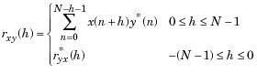

where*h* is the lag and *\** denotes the complex conjugate

### Model

Build model from 6 features of HRV, 5 features of GSR and 12 features of accelerometer to get stress level

TBD

### Diagnosis

Based on stress level

TBD

### Help/Info

Information about Stress features: refers above.

Information about HRV: refers above.

Information about GSR: refers above.

Information about Accelerometer: refers above.

## Sleep

### Sleep introduction

Our application uses activity-aware, multi-modal system that combines accelerometer, resting HR, skin temperature, and Galvanic Skin Response (GSR) information to detect sleep/wake up status and evaluate the sleep quality.

#### Accelerometer

#### Resting HR

#### GSR

#### Skin temperature

### Parameters

Wake up times

Sleep duration

Deep sleep duration

Sleep quality

### Model

TBD

### Diagnosis

Health risks related tosleep duration.

|  |  |  |  |  |  |  |  |  |
| --- | --- | --- | --- | --- | --- | --- | --- | --- |
| **Health risks** | **Gender** | **Sleep duration** | | | | | | |
| 2-4 | ≤5 | 6 | 7 | 8 | 9+ | ≥10 |
| **Diabetes**  Relative risks (95% CIs) | Women  [Ayas03a]  Table 2 |  | 1.37 (1.07–1.77) | 1.13 (0.96–1.34) | 1.00 (0.86–1.18) | 1.00* | 1.36 (1.04–1.73) |  |
| Men  [Yaggi06]  Table 4 |  | 1.95 (0.95–4.01) | 1.95 (1.06–3.58) | 1.00* | 1.41 (0.78–2.55) | 3.12 (1.53–6.37) |  |
| **Coronary heart disease**  Relative risks (95% CIs) | Women  [Ayas03b]  Table 2 |  | 1.39 (1.05–1.84) | 1.18 (0.98–1.43) | 1.10 (0.92–1.31) | 1.00* | 1.37 (1.02–1.85) |  |
| **Obesity**  Odds Ratios(95% CIs) | Women  [Gangwisch05]  Table 3 | 2.34 (1.24-4.41) | 1.93 (1.23-3.03) | 1.25 (0.93-1.68) | 1.00* | 1.39 (1.08-1.80) | 0.84 (0.49-1.46) | 1.06 (0.43-2.57) |
| Men  [Gangwisch05]  Table 3 | 2.51 (0.83-7.53) | 1.07 (0.58-1.97) | 1.24 (0.84-1.82) | 1.00* | 0.78 (0.51-1.17) | 1.93 (0.85-4.36) | 1.06 (0.33-3.39) |
| **Hypertension** |  |  |  |  |  |  |  |  |
| **Metabolic syndrome** |  |  |  |  |  |  |  |  |
|  |  |  |  |  |  |  |  |  |

Health risks related to sleep quality (slow-wave sleep).

Health risks related to sleep disorder Obstructive sleep apnea (OSA). OSA is an oxidative stressdisorder.

### Help/Info

Information about Sleep features: refers above.

Information about Accelerometer: refers above.

Information about Resting: refers above.

Information about GSR: refers above.

Information about Skin temperature: refers above.

## Position

### Patient Position Monitoring

In many cases, it is necessary to monitor the body positions and movements made because of their relationships to particulardiseases (i.e., sleep apnea and restless legs syndrome). Analyzing movements during sleep also helps in determining sleep qualityand irregular sleeping patterns. The body position sensor could help also to detect fainting or falling of elderly people or persons withdisabilities.

The Patient Position monitors six different patient positions (supine, prone, left, right, up sitting/standing, and down sitting/standing)

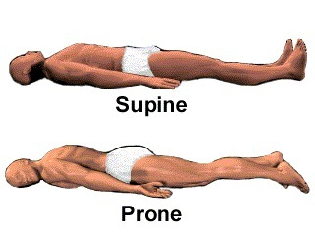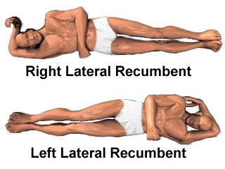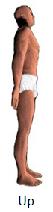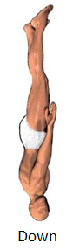

* Supine: Someone in the supine position is lying on his or her back.
* Prone: Someone in the prone position is lying face down.
* Right Lateral Recumbent: The Right lateral recumbent, or RLR, means that the patient is lying on their right side.
* Left Lateral Recumbent: The left lateral recumbent, or LLR, means that the patient is lying on their left side.
* Up: Someone in the up position is sitting/standing up.
* Down: Someone in the down position is sitting/standing down.

### Position detection

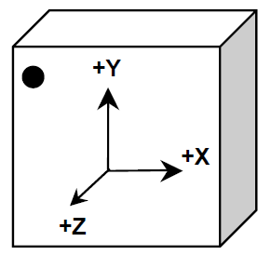

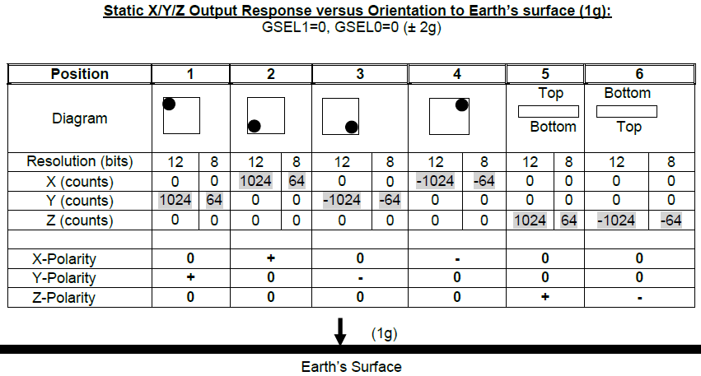

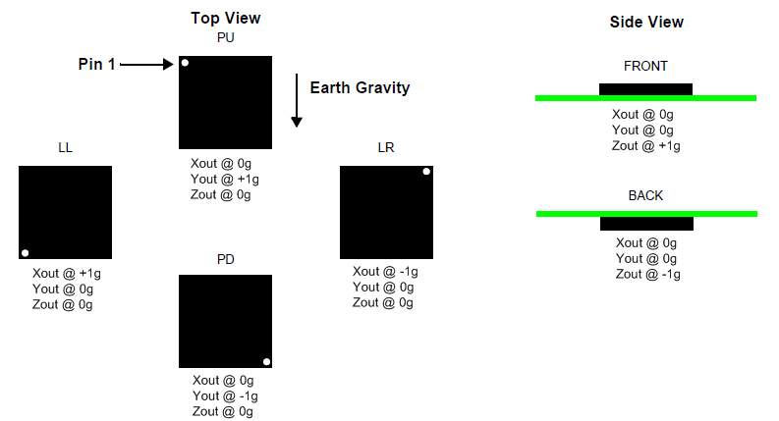

The figure shows the device configuration in the six different orientation modes. These orientations are defined as the following:

PU = Portrait Up, LR = Landscape Right, PD = Portrait Down, LL = Landscape Left, FRONT and BACK side views.

Depending on how the accelerometer is located, the Patient positions will be matched with the accelerometer positions.

For example, in case the top view of accelerometer is located up (opposite to earth gravity direction) and pin 1 is at the same direction of patient head.



|  |  |  |  |  |
| --- | --- | --- | --- | --- |
| Xout | Yout | Zout | Accelerometer | Patient |
| 0 | 0 | 1 | Front | Supine |
| 0 | 0 | -1 | Back | Prone |
| 0 | 1 | 0 | PU | Up |
| 0 | -1 | 0 | PD | Down |
| 1 | 0 | 0 | LL | Right Lateral |
| -1 | 0 | 0 | LR | Left Lateral |
| x | x | x | x | Undefined |

In case the top view of accelerometer is located up (opposite to earth gravity direction) and pin 1 is opposite to patient head.



|  |  |  |  |  |
| --- | --- | --- | --- | --- |
| Xout | Yout | Zout | Accelerometer | Patient |
| 0 | 0 | 1 | Front | Supine |
| 0 | 0 | -1 | Back | Prone |
| 0 | 1 | 0 | PU | Up |
| 0 | -1 | 0 | PD | Down |
| 1 | 0 | 0 | LL | Left Lateral |
| -1 | 0 | 0 | LR | Right Lateral |
| x | x | x | x | Undefined |

The rawXout, Yout, Zout values should be preprocessed using thresholding before they are used for position detection. The temporary threshold for each axis is+/- 0.2g as defined below:

$$X= \left\{\begin{matrix}0 & \left|X\right|<0.2 \\ 1 & X>0.8 \\ -1 & X< -0.8\end{matrix}\right.$$

### Help/Info

Information about Position features: refers above.

## Fertility

### Parameters

* Start of period: Users manually input.
* Cycle length:

Cycle_length (*i*) = Start_of_period(*i*+1) – Start_of_period(*i*)

Where *i*: cycle #

* Maximum Temperature date: the date which has maximum temperature during one cycle.
* Mid-cycle date: the date at the middle of the cycle.
* Ovulation date:

**If abs**(Maximum_Temperature_date (*i*) – Mid-cycle_date(*i*)) <=5

Ovulation_date(*i*) = Maximum_Temperature_date(*i*)

**Else**

Ovulation_date(*i*) = Mid-cycle_date(*i*)

**End**

* Ovulation time: # of days from the start of one period to the next ovulation date

Ovulation_time(*i*) = Ovulation_date(*i*) - Start_of_period(*i*)

* Most fertile time: 5 days prior ovulation date and 2 days later.

Most_fertile_time_start(*i*) = Ovulation_date(*i*) - 5

Most_fertile_time_end(*i*) = Ovulation_date(*i*) + 1

* Most pregnant time: the day prior to and the day of ovulation

Most_pregnant_time_start(*i*) = Ovulation_date(*i*) - 1

Most_pregnant_time_end(*i*) = Ovulation_date(*i*)

### Statistics

* Cycles tracked N: # of cycles tracked
* Average cycle length
* Cycle length variation

Cycle_length_variation = sqr(standard_deviation_of_cycle_length)

* Average ovulation time
* Longest cycle
* Shortest cycle

### Advanced Prediction

Advance prediction should be done after 3 months of tracking.

* Prediction of start of next period

Start_of_next_period = round(start_of_last_period + Average_cycle_length)

* Prediction of next ovulation date

Next_ovulation_date = round(start_of_last_period + Ovulation_time)

* Prediction of next most fertile time

Next_most_fertile_time_start = Next_ovulation_date - 5

Next_most_fertile_time_end = Next_ovulation_date + 1

* Prediction of next most pregnant time

Next_most_pregnant_time_start = Next_ovulation_date - 1

Next_most_pregnant_time_end = Next_ovulation_date

### Help/Info

Information about fertile time: A woman‘s most fertile time spans about 6 days, starting approximately 5 days prior to ovulation, but there are only 2 days when you are most likely to become pregnant: the day prior to and the day of ovulation. Ovulation days can vary from cycle to cycle. A woman's body temperature only rises AFTER she has ovulated.

Tips for Taking Your Basal Body Temperature

* Begin taking your temperature on the first day of your period.
* Take it at about the same time every day, preferably before you get out of bed in the morning and before any activity.
* Don't do anything -- eat, drink, smoke, or even move around -- before you take your temperature.
* You can take your temperature however you want -- orally, at ear or armpit -- but make sure you use the same technique each time.
* Keep in mind that you will probably get some occasional freak readings -- either high or low temperatures -- that don't fit into the larger pattern. If they don't happen often, don't worry about them.
* You may want to have your doctor look at your chart to help you interpret it.

# Conversion Formulas

|  |  |
| --- | --- |
| **BEGIN WITH** | **FORMULA for CONVERTING** (Multiply Number of Units by Conversion Number to Obtain New Number of Units) |
| **centimeters (cm)** | centimeters x 0.3931 = inches |
| **kilometers (km)** | kilometers x 0.6214 = miles |
| **inches (in)** | inches x 2.5441 = centimeters |
| **feet (ft)** | feet x 12 = inches |
| **miles (mi)** | miles x 5280 = feet  miles x 1.609 = kilometers |
| **Temperature Conversions** | |
| **degrees Fahrenheit (F)** **degrees Celsius (C)** | (F - 32) x 5/9 = C |
| (C x 1.8) + 32 = F |
| **Weights and Measures** (Left Column Equals Right Column) | |
| **pound (lb)** | pounds x 0.4536 = kilograms |
| **kilograms (kg)** | kilograms x 2.2046= pounds |

# References